A507-Mex-Veracruz-Nopiloa-Smiling Figure-Standing-Terra cotta-600-800 CE

**Case No.: 10**

**Accession No.**

**Formal Label:** Mex-Veracruz-Nopiloa-Smiling Figure-Standing-Terra cotta-600-800 CE

**Display Description:**

The major theme of Classic Veracruz art is human sacrifice, particularly in context of the Mesoamerican ballgame.[[2]](https://en.wikipedia.org/wiki/Classic_Veracruz_culture#cite_note-2) This art is rendered with extensive and convoluted banded scrolls that can be seen both on monumental architecture and on portable art, including ceramics and even carved bones. At least one researcher has suggested that the heads and other features formed by the scrolls are a Classic Veracruz form of pictographic writing.[[3]](https://en.wikipedia.org/wiki/Classic_Veracruz_culture#cite_note-3) This scrollwork may have grown out of similar styles found in Chiapa de Corzo and Kaminaljuyu.[[4]](https://en.wikipedia.org/wiki/Classic_Veracruz_culture#cite_note-4)

**LC Classification:**

**Date or Time Horizon:**

**Geographical Area:**

**Map:**

* 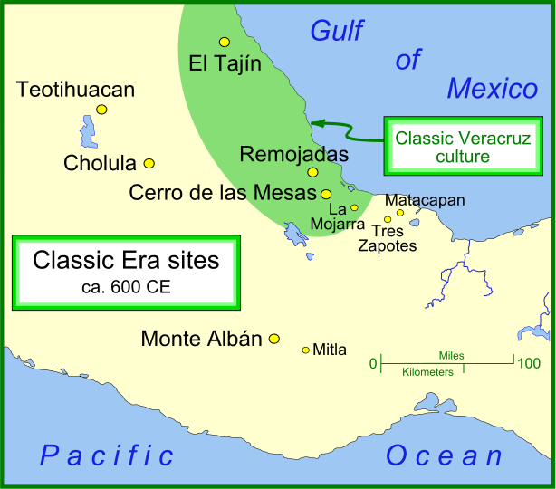
* By Madman2001 - Own work, CC BY-SA 3.0, <https://commons.wikimedia.org/w/index.php?curid=18422641>
* 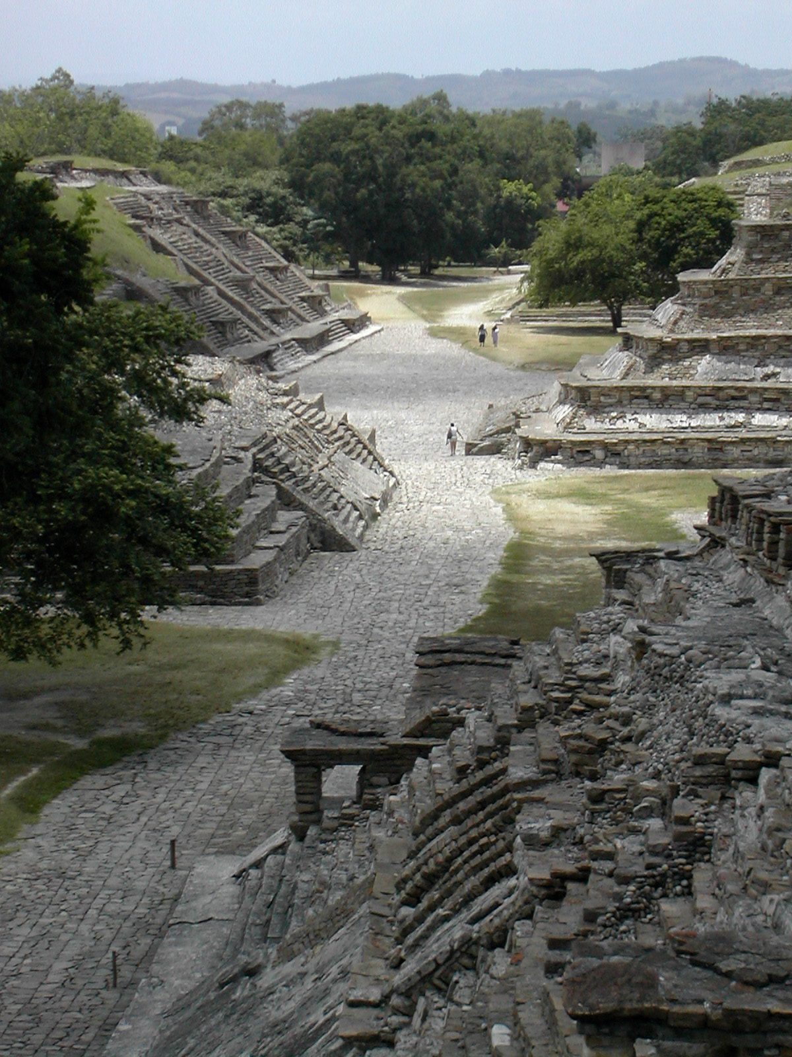
* [El Tajín](https://en.wikipedia.org/wiki/El_Taj%C3%ADn), a [Totonac](https://en.wikipedia.org/wiki/Totonac) ruin in the municipality of [Papantla](https://en.wikipedia.org/wiki/Papantla), [Veracruz](https://en.wikipedia.org/wiki/Veracruz), [Mexico](https://en.wikipedia.org/wiki/Mexico). https://upload.wikimedia.org/wikipedia/commons/thumb/c/cd/El_Taj%C3%ADn_1.jpg/675px-El_Taj%C3%ADn_1.jpg

**GPS coordinates:**

**Cultural Affiliation:**

**Media:**

**Dimensions:**

**Weight:**

**Condition:**

**Provenance:**

**Discussion:**

**References:**